A Ready To Use Web-Application Providing a

Personalized Biopsy Schedule for Men With Low-Risk PCa Under Active Surveillance*?*

Anirudh Tomer, MSca,∗, Daan Nieboer, MScb, Monique J. Roobol, PhDc, Anders Bjartell, MD, PhDd, Ewout W. Steyerberg, PhDb,e, Dimitris

Rizopoulos, PhDa, Movember Foundations Global Action Plan Prostate Cancer Active Surveillance (GAP3) consortiumf

*aDepartment of Biostatistics, Erasmus University Medical Center, Rotterdam, the*

*Netherlands*

*bDepartment of Public Health, Erasmus University Medical Center, Rotterdam, the*

*Netherlands*

*cDepartment of Urology, Erasmus University Medical Center, Rotterdam, the Netherlands dDepartment of Urology, Sk˚ane University Hospital, Malm¨o, Sweden eDepartment of Biomedical Data Sciences, Leiden University Medical Center, Leiden, the*

*Netherlands*

*fThe Movember Foundations Global Action Plan Prostate Cancer Active Surveillance (GAP3) consortium members presented in Appendix A*

**Abstract**

**Background:** Prostate cancer active surveillance (AS) patients undergo repeat biopsies. Treatment commonly advised when biopsy Gleason grade ≥ 2 (reclassification). Many patients never experience reclassification, yet undergo biopsies frequently. Reclassification risk based personalized biopsy

Word Count Abstract: 300; Word Count Text: 2500

Corresponding author (Anirudh Tomer): Erasmus MC, kamer flex Na-2823, PO Box

2040, 3000 CA Rotterdam, the Netherlands. Tel: +31 10 70 43393

*Email addresses:* a.tomer@erasmusmc.nl (Anirudh Tomer, MSc),

d.nieboer@erasmusmc.nl (Daan Nieboer, MSc), m.roobol@erasmusmc.nl (Monique J.

Roobol, PhD), anders.bjartell@med.lu.se (Anders Bjartell, MD, PhD),

e.w.steyerberg@lumc.nl (Ewout W. Steyerberg, PhD), d.rizopoulos@erasmusmc.nl

(Dimitris Rizopoulos, PhD)

schedules may reduce patient burden.

**Objective:** Develop web-application to assist patients/doctors make better biopsy decisions than fixed biopsies.

**Design, Setting, and Participants:** Model development: World’s largest AS study PRIAS, 7813 patients, 1134 experienced reclassification; External validation: largest five GAP3 database cohorts; Data: prostatespecific antigen (PSA), repeat biopsy Gleason grade.

**Outcome Measurements, and Statistical Analysis:** Bayesian joint

model fitted to PRIAS dataset. Model predicted patient-specific reclassification risk utilized for personalized biopsy decisions. Model validated in GAP3 cohorts using risk prediction error, calibration, area under ROC (AUC). Risk calculator, personalized schedules implemented in web-application, for PRIAS and validated GAP3 cohorts.

**Results and Limitations:** Reclassification rate at year five of followup: 35% in PRIAS, at most 50% in GAP3 cohorts. PSA velocity stronger predictor of reclassification (Hazard Ratio: 2.47, 95%CI: 1.93–2.99), than PSA value (Hazard Ratio: 0.99, 95%CI: 0.89–1.11). Validation: Moderate AUC (0.55–0.75) in PRIAS and GAP3 cohorts. Moderate prediction error (0.1–0.3) in GAP3 cohorts with Reclassification rate similar to PRIAS, large (0.3–0.45) otherwise. Model recalibrated for external GAP3 cohorts.

**Conclusions:** We successfully developed and validated web-application for predicting reclassification risks, and risk based personalized biopsy decisions, in prostate cancer AS. Available for PRIAS, and largest five GAP3 database cohorts. Enables shared decision making of biopsy schedules by comparing fixed and personalized schedules on total biopsies and expected time delay in detection of reclassification.

**Patient Summary:** Reclassification risk based personalized biopsy schedules are novel alternative to fixed biopsy schedules. They are implemented in our web-application. May offer better balance between total biopsies and time delay in detection of reclassification than fixed schedules.

*Keywords:* Active Surveillance, Biopsies, Personalized Medicine, Prostate

Cancer, Shared Decision Making

1. **1. Introduction**
2. Patients with low- and very low-risk screening-detected localized prostate cancer are usually advised active surveillance (AS) instead of immediate radical treatment [1]. In AS, cancer progression is routinely monitored via prostate-specific antigen (PSA), digital rectal examination, and repeat biop-sies. Among these, the strongest indicator of cancer-related outcomes is the biopsy Gleason grade [2]. When the Gleason grade increases from grade 1 8 (Gleason 3+3) to 2 (Gleason 3+4) or higher, called *reclassification*, patients 9 are commonly advised curative treatment [3].
3. Biopsies are conducted periodically. Consequently, reclassification is al-
4. ways detected with a time delay (Figure 1). For detecting reclassification

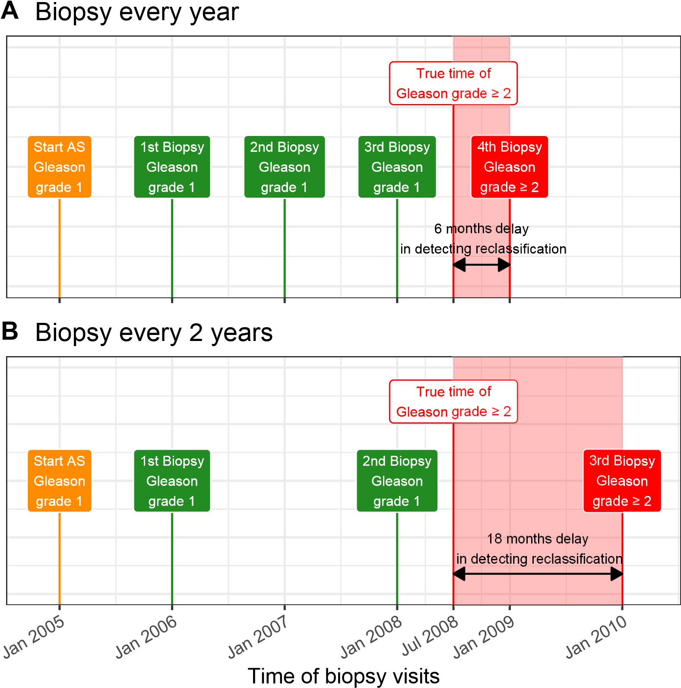

Figure 1: **Trade-off between the number of biopsies and time delay in detecting reclassification (Increase in Gleason grade from 1 to 2 or higher):** The true time of reclassification for the patient in this figure is July 2008. When biopsies are scheduled annually (**Panel A**), reclassification is detected in January 2009 with a time delay of six months, and a total of four biopsies are scheduled. When biopsies are scheduled biennially (**Panel B**), reclassification is detected in January 2010 with a time delay of 18 months, and a total of three biopsies are scheduled. Since biopsies are conducted periodically, the time of reclassification is observed as an interval. For example, between Jan 2008–Jan 2009 in **Panel A** and between Jan 2008–Jan 2010 in **Panel B**.

1. timely, many AS programs schedule fixed and frequent biopsies (e.g., annu-ally) for all patients [4, 5]. However, this leads to many unnecessary biopsies in slow/non-progressing patients. Biopsies are invasive, painful, and prone to medical complications. Thus, biopsy burden and patient non-compliance to frequent biopsies [6] has raised concerns regarding the optimal biopsy schedule [7, 8]. To this end, infrequent schedules such as biennial biopsies have been proposed as an alternative [7, 9]. Although, biennial biopsies may still lead to five unnecessary biopsies over ten years (current study period of large AS programs) for slow/non-progressing patients. A promising alternative to fixed and frequent biopsies is personalized biopsy schedules based on the 22 patient-specific risk of reclassification (Figure 2).
2. The first challenge in developing personalized biopsy schedules is consol-
3. idating accumulated patient data (e.g., PSA, previous biopsy results) into
4. risk estimates for reclassification. Existing calculators for risk of reclassification [10, 11] use only the latest PSA measurement of a patient. In contrast, we intend to utilize all repeated measurements of PSA, previous biopsy results, and baseline characteristics of a patient. To this end, a suitable model is the joint model for time-to-event and longitudinal data [12, 13, 14]. A joint model predicts risk of reclassification in a personalized manner. A subsequent challenge, however, is translating risks into clinical decisions. For example, a 10% risk of reclassification can be perceived high/low depending upon the patient age. Patients may also weigh risks of reclassification with the potential *consequences* of another biopsy. Two relevant *consequences* of biopsies (Figure 1) are the timing and total number of biopsies (burden), and the time delay in detecting reclassification (smaller is beneficial). The relative importance of these *consequences* can vary between the patients, and 38 also over the follow-up period for the same patient.

**A** Should a biopsy be conducted at current visit?

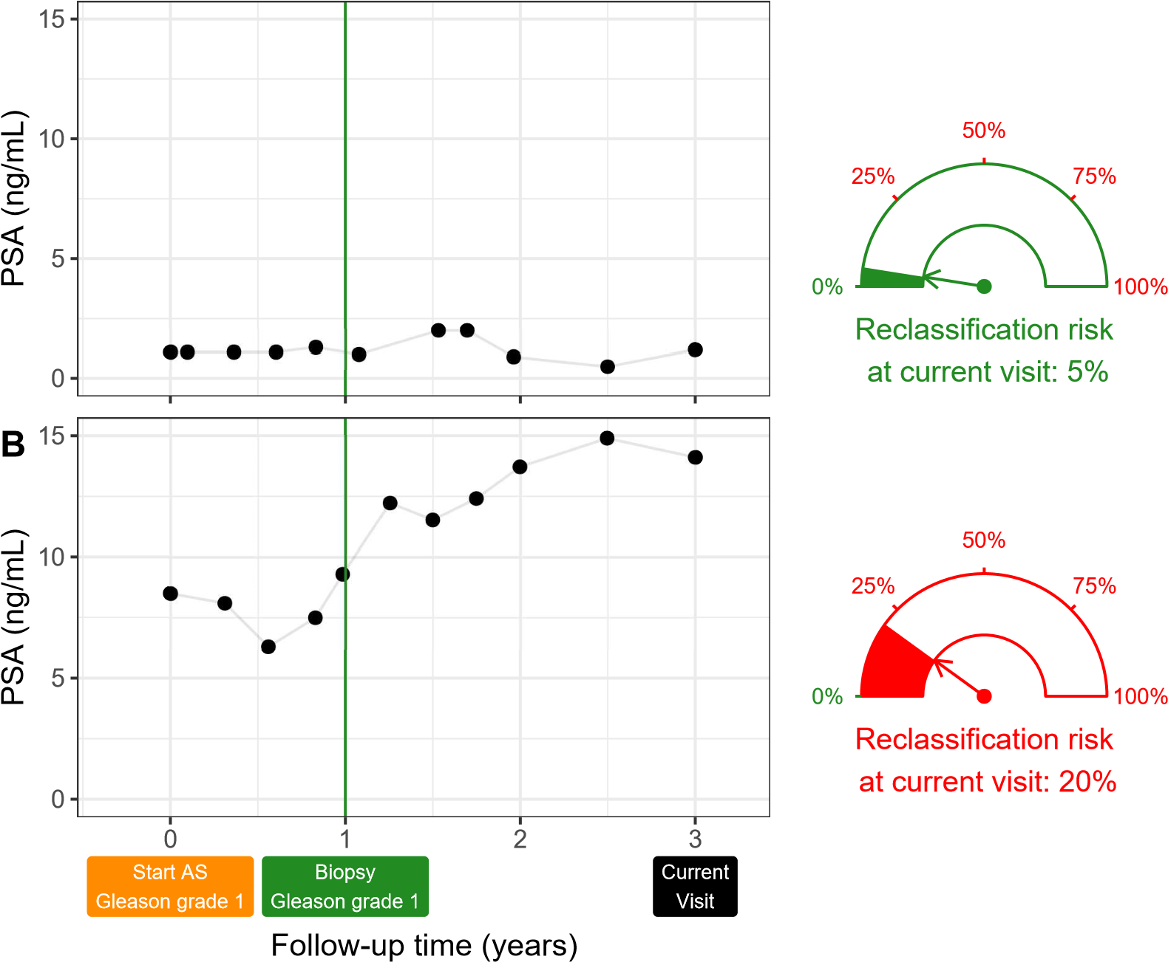

Figure 2: **Motivation for personalized risk-based decisions of biopsy**: Patient A (**Panel A**) and B (**Panel B**) had their latest biopsy at year one of follow-up (green vertical line). Patient A’s prostate-specific antigen (PSA) profile remained stable until his current visit at year three, whereas patient B’s profile has shown a rise. Consequently, patient B’s cumulative risk of reclassification at the current visit (year three) is higher than that of patient A. This makes patient B a more suitable candidate for biopsy than Patient A.

Risk estimates in this figure are only illustrative.

37

The goal of this work is to create a web-application for assisting patients/doctors in making better biopsy decisions during AS than fixed biopsies. Using this web-application, we intend to provide patients their current and future personalized risk of reclassification and risk-based personalized 43 biopsy schedules. To facilitate shared decision making of biopsy schedules, we also aim to provide quantitative estimates of *consequences* for both personalized and fixed schedules. In order to reach a large number of patients, we will use the world’s largest AS dataset PRIAS, and Global Action Plan Prostate Cancer Active Surveillance’s (GAP3) largest five AS datasets, for 48 development and validation, respectively.

49 **2. Patients and Methods**

# 50 2.1. Study Cohort

1. For developing a statistical model to power our web-application, we used
2. the Prostate Cancer International Active Surveillance (PRIAS) database. It
3. is an ongoing (December 2006 – to date) prospective cohort study of men with low- and very-low risk prostate cancer diagnoses [3]. More than 100 medical centers from 17 countries contributed to PRIAS, using a common protocol [(https://www.prias-project.org)](https://www.prias-project.org/). Upon inclusion in PRIAS, PSA was 57 measured quarterly for the first two years of follow-up and semiannually thereafter. Biopsies were scheduled at year one, four, seven, and ten of follow-up. Additional yearly biopsies were scheduled when PSA doubling time was between zero and ten years.
4. We selected all 7813 patients who had Gleason grade 1 [2] at the time of
5. inclusion in PRIAS (Table 1). Our primary event of interest is increase in
6. this Gleason grade upon repeat biopsy, called *reclassification* (1134 patients). Reclassification is a trigger for treatment advice in PRIAS. Although, 2250 patients were provided treatment on the basis of their PSA, or number of biopsy cores with cancer, or anxiety/other reasons. Our reasons for focusing solely on reclassification are, namely, reclassification is strongly associated with cancer-related outcomes, and other triggers for treatment vary between 69 cohorts.
7. Table 1: Summary of the PRIAS dataset. The primary event of interest is reclassification, that is, increase in Gleason grade from grade 1 to 2 or higher. IQR: interquartile range,
8. PSA: prostate-specific antigen.

|  |  |
| --- | --- |
| Characteristic | Value |
| Total patients | 7813 |
| Reclassification (primary event) | 1134 |
| Treatment | 2250 |
| Watchful waiting | 334 |
| Loss to follow-up | 250 |
| Death (unrelated to prostate cancer) | 95 |
| Death (related to prostate cancer) | 2 |
| Median age at diagnosis (years) | 66 (IQR: 61–71) |
| Median follow-up period per patient (years) | 1.8 (IQR: 0.9–4.0) |
| Total PSA measurements | 67578 |
| Median number of PSA measurements per patient | 6 (IQR: 4–12) |
| Median PSA value (ng/mL) | 5.7 (IQR: 4.1–7.7) |
| Total biopsies | 15686 |
| Median number of biopsies per patient | 2 (IQR: 1–2) |

# 70 2.2. Statistical Model

1. To create personalized biopsy schedules based on patient-specific risk of
2. reclassification, we required a risk prediction model. Available data was patient age at inclusion in AS, longitudinally measured PSA, timing of repeat biopsies and corresponding Gleason grades, and observed time of reclassification. Analysis of this data required modeling the within-patient correlation for PSA, association between the Gleason grades and PSA profiles of a patient, and handling missing PSA measurements after a patient experienced reclassification. In such situations, a commonly used model is the joint model 79 for time-to-event and longitudinal data [12, 13, 14].
3. Our joint model consisted of two sub-models. First, a linear mixed
4. model [15] for longitudinally measured PSA (log-transformed). Second, a
5. relative-risk model (similar to Cox model) for obtaining the risk of reclas-
6. sification. In the model for PSA, we fitted a curve to PSA measurements
7. (Panel A, Figure 3). From each patient’s fitted PSA profile, we extracted
8. the instantaneous PSA velocity. This velocity varies over time (Panel B,
9. Figure 3). Consequently, it is more precise than the currently used constant PSA velocity assumption [16]. We connected the two sub-models by using the fitted PSA and instantaneous velocity as predictors in the sub-model for risk of reclassification (Panel C, Figure 3). Patient age was included in both sub-models. The parameters of the two sub-models were estimated jointly 91 (Supplementary A) using the R package **JMbayes** [17].

# 92

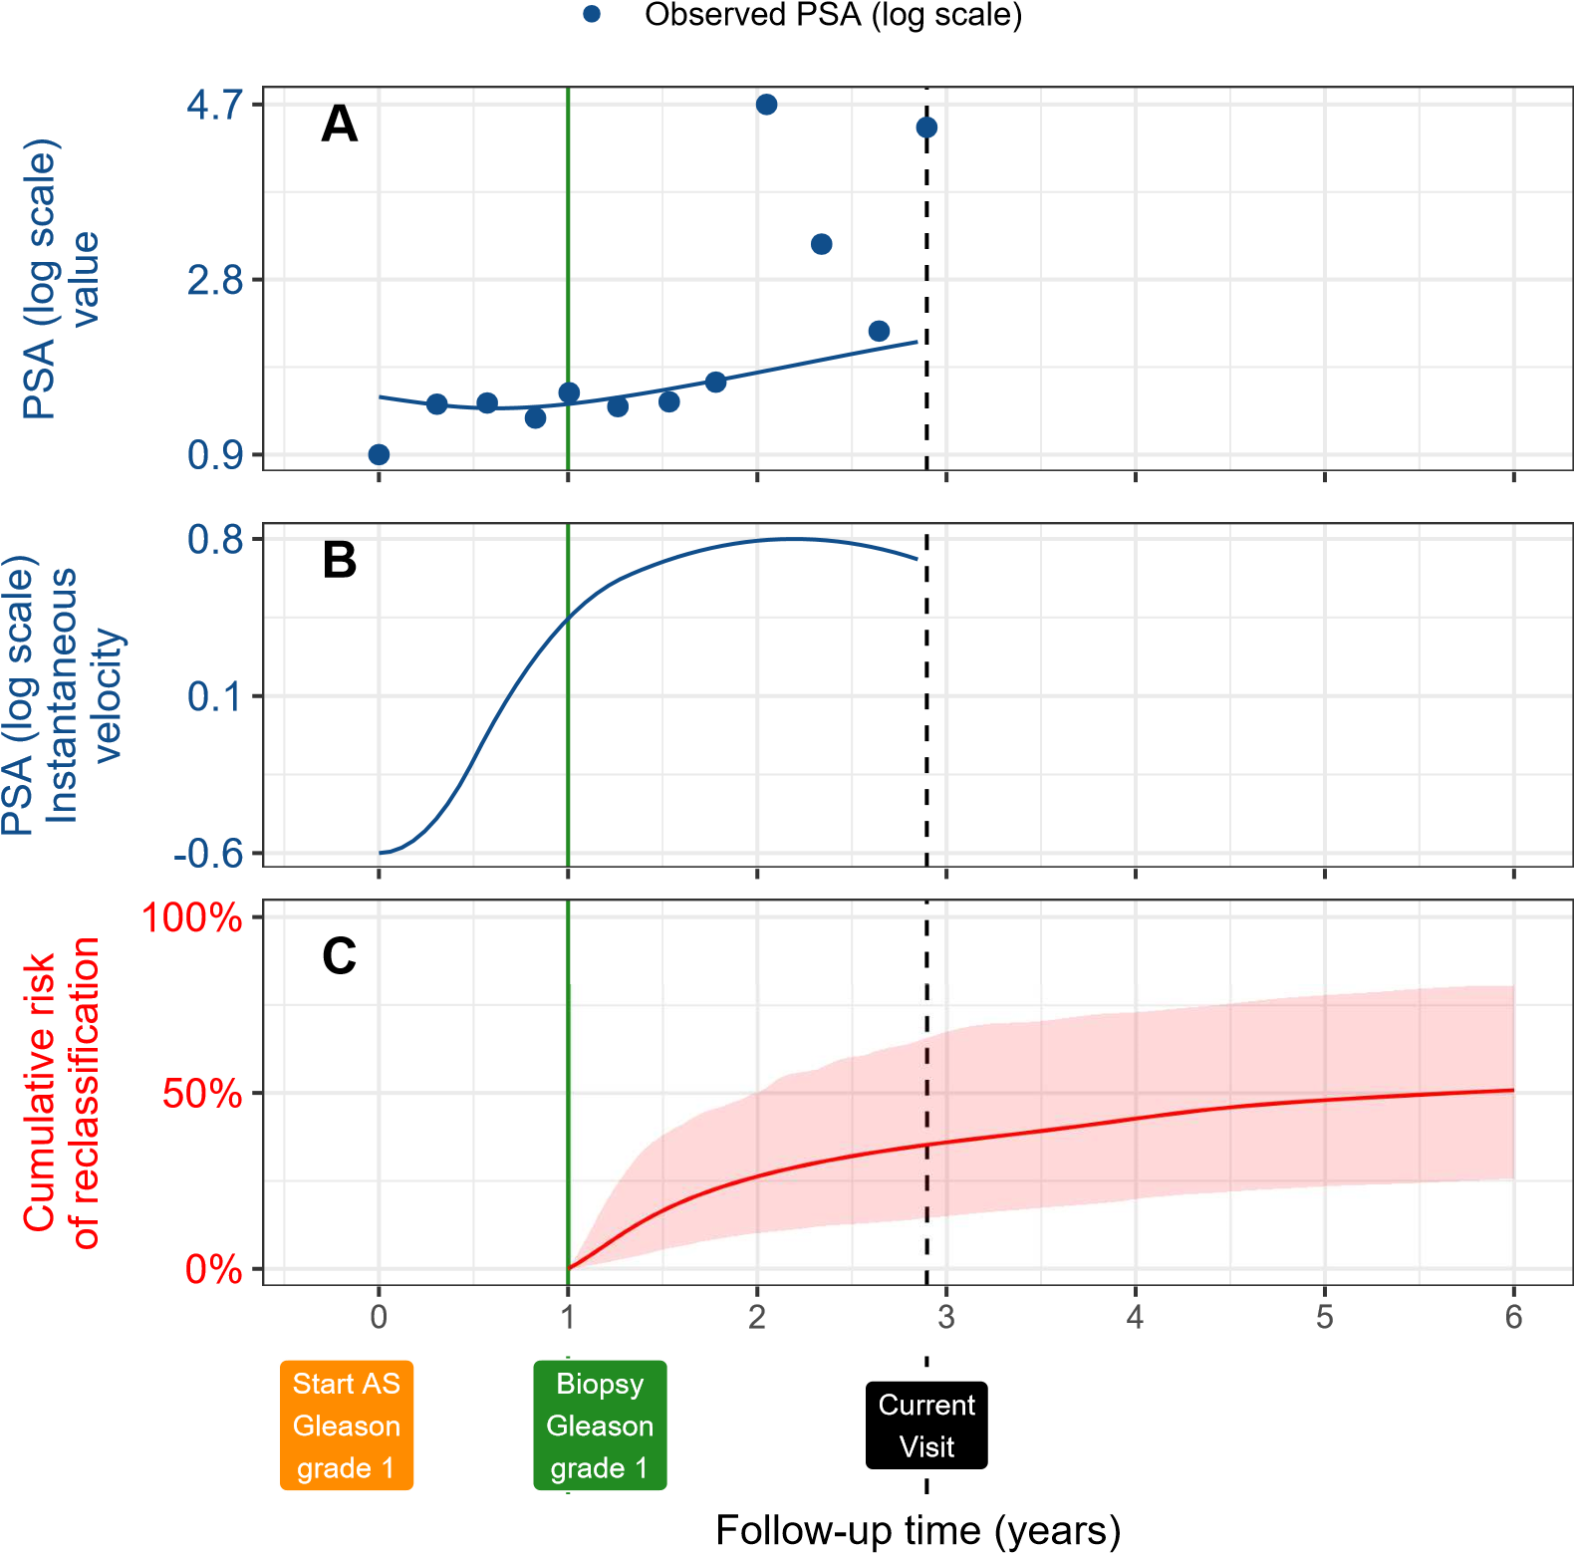

Figure 3: **Illustration of the joint model on a real PRIAS patient**. **Panel A:** Observed PSA (blue dots) and fitted PSA (solid blue line), log-transformed. **Panel B:** Estimated instantaneous velocity of PSA (log-transformed). **Panel C**: Predicted cumulativerisk of reclassification (95% credible interval shaded). Reclassification is defined as an increase in Gleason grade from grade 1 to 2 or higher. This risk of reclassification is available starting from the time of the latest negative biopsy (vertical green line at year 1 of follow-up). The joint model estimated it by combining the fitted value and fitted instantaneous velocity of PSA (log scale), and time of the latest negative biopsy. Black dashed line at year 3 denotes the time of current visit.

# 2.3. Risk of Reclassification Based Personalized Biopsies

1. The key component in personalized schedules is the cumulative-risk of reclassification. Given a patient’s accumulated PSA measurements and biopsy results, our joint model predicted the cumulative-risk of reclassification at his current as well as future visit times (Panel C, Figure 3). This cumulative-risk is updated with more patient data over follow-up (Figure 5, Supplementary B).
2. In PRIAS, patient PSA was measured every six months. If during a PSA
3. visit, a patient’s predicted cumulative-risk of reclassification was more than a certain threshold (e.g., 10%), we scheduled an immediate biopsy. We scheduled future biopsies too because our model predicts patient’s cumulative-risk at his future follow-up visits as well. We achieved this by repeatedly applying the same risk threshold rule at each future follow-up visit (Supplementary C). We maintained a minimum gap of one year between consecutive biopsies (PRIAS recommendation). Example personalized schedules based on 5% and 10% risk thresholds are shown in Panel B, Figure 4. Due to the currently limited follow-up period of PRIAS, we were able to schedule biopsies during the first six years of follow-up only (Table 12, Supplementary C).
4. The choice of the risk threshold in the personalized schedule dictates the *consequences* of following that schedule. *Consequences* are the timing
5. and the total number of biopsies, and the expected time delay in detecting
6. reclassification. Our model estimated *consequences* in a personalized manner (Panel B,C in Figure 4, and Figure 9–11 in Supplementary C) given any schedule of biopsies. Thus, patients can compare personalized schedules based on different risk thresholds, with fixed schedules, before making a 117 choice.

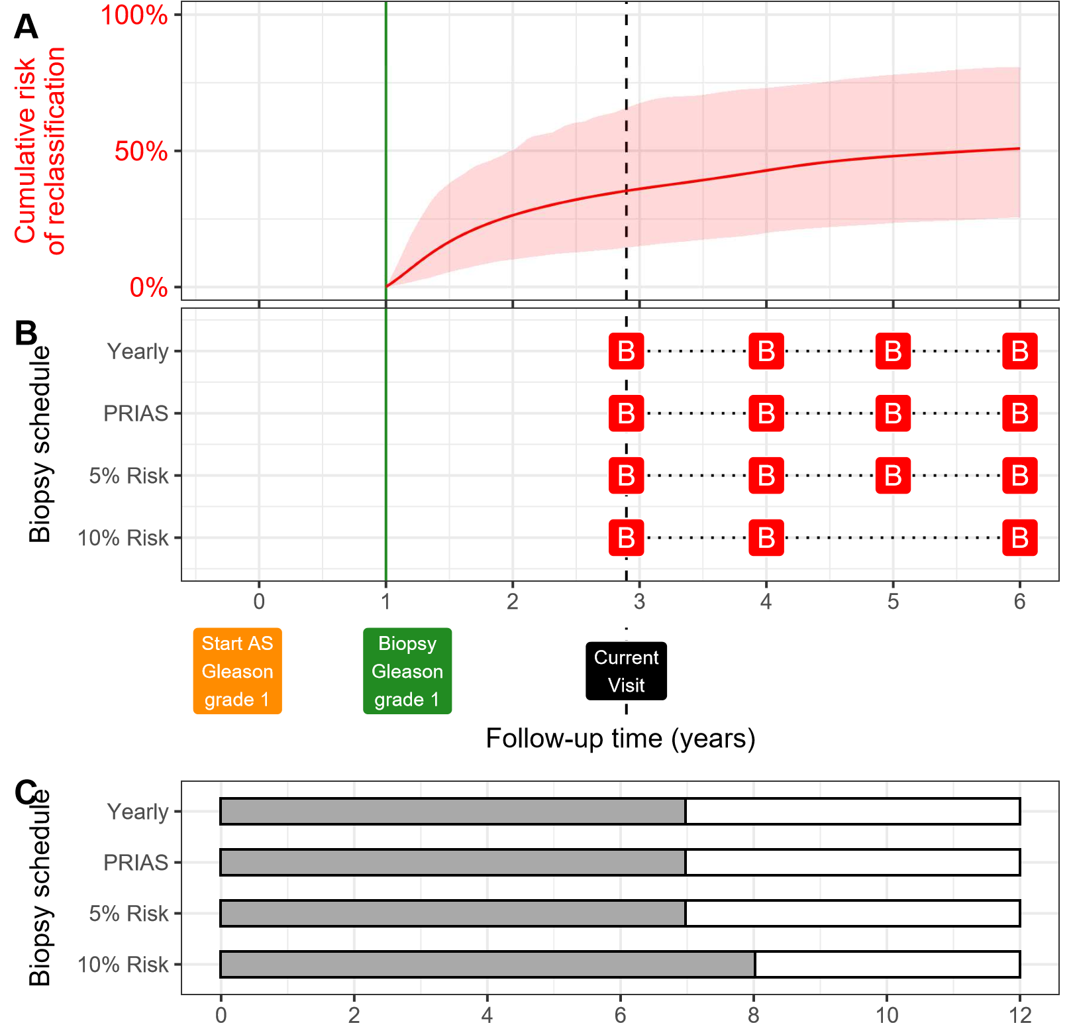

Expected delay (months) in detecting reclassification

Figure 4: **Illustration of personalized and fixed schedules of biopsies**. The PSA profile of this patient is shown in Figure 3. **Panel A:** Predicted cumulative-risk of reclassification (95% credible interval shaded). **Panel B:** Personalized and fixed schedules of biopsies, with a red ‘B’ indicating a scheduled biopsy. Green vertical line at year 1 denotes the time of latest negative biopsy. Black dashed line at year 3 denotes time of current visit. **Panel C:** Expected time delay in detecting reclassification (months) for different schedules.

# 118 2.4. Model Validation

1. We validated our model internally using the PRIAS cohort, and externally using the largest five GAP3 database [18] cohorts. These were, namely, University of Toronto AS (Toronto), Johns Hopkins AS (Hopkins), Memorial Sloan Kettering Cancer Center AS (MSKCC), King’s College London AS (KCL), and Michigan Urological Surgery Improvement Collaborative AS (MUSIC). We assessed our model’s ability to discriminate between patients who experience/do not experience reclassification, via the area under the receiver operating characteristic curve or AUC [19]. We employed calibration plots [20, 21] and mean absolute prediction error [19] to graphically and quantitatively evaluate the prediction accuracy of our model. Due to the longitudinal nature of AS studies, the AUC and prediction error varies over follow-up (Supplementary B.1). Lastly, we resolved model miscalibration in external GAP3 cohorts by recalibrating our model’s baseline hazard of 132 reclassification, individually for each GAP3 cohort (Supplementary B.1).

# 133 2.5. Web-Application

1. We implemented our methodology in a web-application <https://emcbiostatistics>. [shinyapps.io/prias_biopsy_recommender/.](https://emcbiostatistics.shinyapps.io/prias_biopsy_recommender/) It utilizes the joint model fit136 ted to the PRIAS dataset. Currently, the web-application supports PRIAS and the five external cohorts in which we validated our model. Patient data can be entered manually or can be uploaded in Microsoft Excel format. Predictions for risk of reclassification are shown for a currently limited, cohort-specific, follow-up period (Table 12, Supplementary C). The web-application allows comparison of the *consequences* of following these schedules: personalized schedules based on 5%, 10%, and 15% risk threshold; annual biopsies; 143 biennial biopsies; and PRIAS schedule.
2. **3. Results**
3. The rate of reclassification at year five of follow-up was 35% in PRIAS,
4. and at most 50% in the five validation GAP3 cohorts (Panel B, Figure 5).
5. That is, many patients do not require any biopsy in the first five years of AS.
6. In the fitted joint model, when patient age increased from 61 to 71 years (25-th to 75-th percentile), the adjusted hazard ratio of reclassification was 1.45 (95%CI: 1.30–1.63). When fitted PSA value (log scale) increased from 2.36 to 3.07 (25-th to 75-th percentile), the adjusted hazard ratio was 0.99 (95%CI: 0.89–1.11). When estimated instantaneous PSA (log scale) velocity increased from -0.09 to 0.31 (25-th to 75-th percentile), the adjusted hazard ratio was 2.47 (95%CI: 1.93–2.99). Hence, instantaneous velocity of PSA was a stronger predictor of reclassification than PSA value. Detailed parameter estimates are in Supplementary A.2.
7. The time-varying mean absolute prediction error, time-varying AUC, and
8. calibration plot of our model in different cohorts are shown in Panel B, Figure 8, Supplementary B; Panel A, Figure 5; and Panel B, Figure 5, respectively. The AUC was moderate (0.55 to 0.75) in all cohorts. Mean absolute prediction error was large (0.3 to 0.45) in cohorts with rate of reclassification different from PRIAS, and moderate (0.1 to 0.3) otherwise. Our model required recalibration of baseline hazard of reclassification in all cohorts (Figure 6, Supplementary B). Although, calibration was fine in Johns Hopkins cohort, whose rate of reclassification was similar to PRIAS (Panel B, Figure 5). The risk predictions from the recalibrated models were as good as risk predictions from joint models fitted separately to each cohort (Figure 7, Supplementary B). Comprehensive validation results are in Supplementary B.
9. 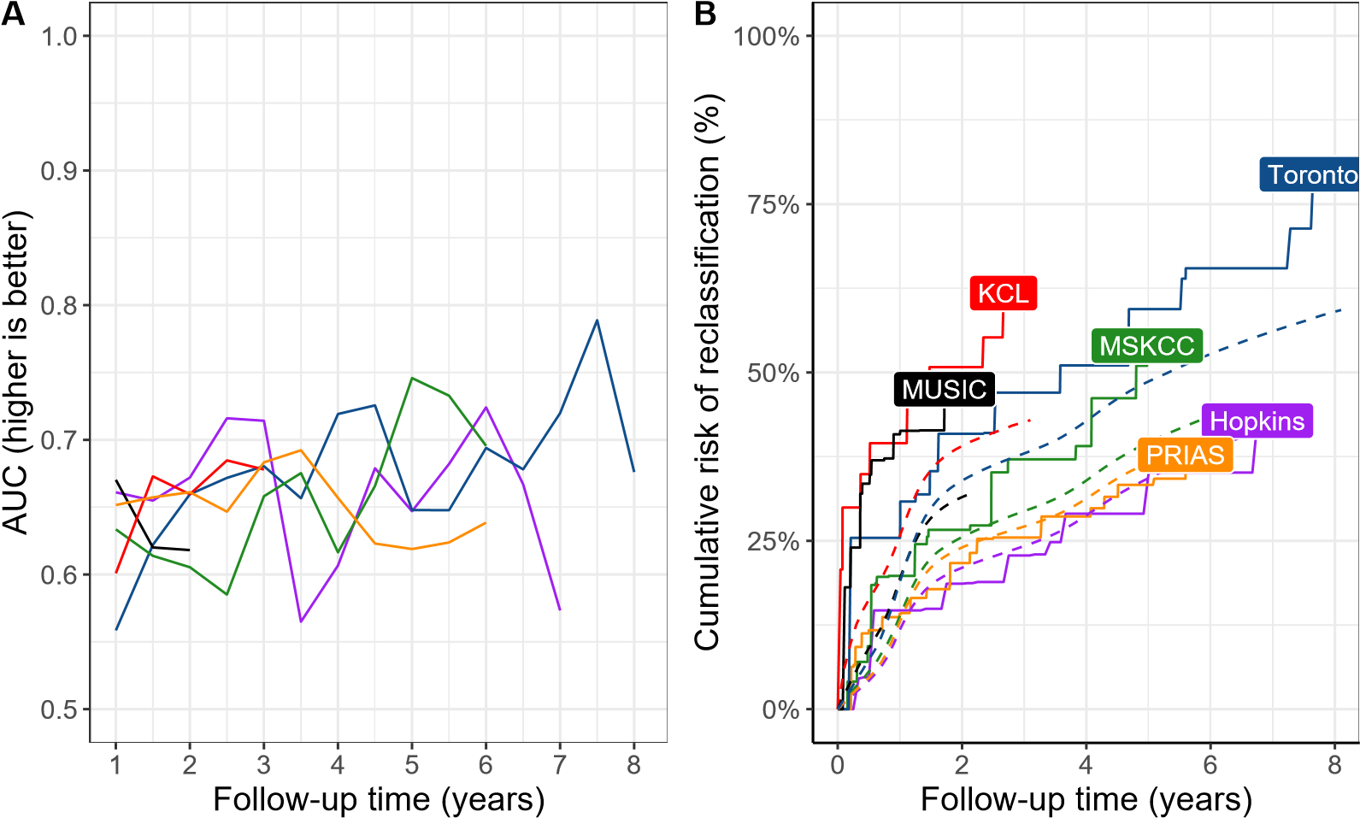
10. HopkinsMSKCCKCL
11. TorontoMUSICPRIAS
12. Figure 5: **Model Validation Results**. **Panel A**: time dependent area under the receiver operating characteristic curve or AUC (measure of discrimination). **Panel B**: calibration at-large [20, 21], with solid lines depicting the non-parameteric estimate of the cumulative-risk of reclassification [22], and dashed lines showing the average cumulative-risk of reclassification obtained using the joint model fitted to the PRIAS dataset. Full names of Cohorts are *PRIAS*: Prostate Cancer International Active Surveillance, *Toronto*: University of Toronto Active Surveillance, *Hopkins*: Johns Hopkins Active Surveillance, *MSKCC*: Memorial Sloan Kettering Cancer Center Active Surveillance, *KCL*: King’s College London Active Surveillance, *MUSIC*: Michigan Urological Surgery Improvement Collaborative Active Surveillance.
13. Various personalized and fixed biopsy schedules for a demonstration patient in Figure 4 show that a personalized schedule based on 10% risk threshold leads to one less biopsy than other schedules. At the same time, the corresponding time delay in detection of reclassification is expected to be only one month more than other schedules. A compulsory biopsy was scheduled at year six (maximum biopsy scheduling time in PRIAS, Supplementary C) in all schedules for a meaningful comparison between them. Additional demonstrations are in Figure 9–11, Supplementary C.
14. **4. Discussion**
15. We developed a web-application for assisting patients/doctors in making biopsy decisions during prostate cancer active surveillance (AS). Our web-application provides the patient’s current and future risks of reclassification (increase in Gleason grade [2] from grade 1 to 2 or higher), and personalized biopsy schedules based on this risk. Our work has four novel features over earlier risk calculators [13, 23]. First, for personalized biopsy schedules, we developed a statistical model using the world’s largest AS dataset PRIAS. Second, for following any biopsy schedule, fixed or personalized, our model predicts the corresponding time delay in detection of reclassification (less is beneficial). Thus, patients/doctors can compare schedules before making a choice. Third, we externally validated our model in the largest five GAP3 database [18] AS cohorts. Fourth, we implemented our methodology 190 in a web-application ([https://emcbiostatistics.shinyapps.io/prias_ biopsy_recommender/)](https://emcbiostatistics.shinyapps.io/prias_biopsy_recommender/) for PRIAS and validated GAP3 cohorts.
16. Currently, biopsies are decided either according to fixed schedules (e.g., annual biopsies) or utilize PSA. Both approaches have drawbacks [16, 6]. In particular, PSA has not been exploited fully and correctly. For example, using observed PSA is incorrect because it has measurement error. Other approaches utilize only the latest PSA, and/or when they utilize all PSA data, they assume constant PSA velocity. In contrast, our model employs all PSA measurements to build a patient-specific profile of PSA. This profile is allowed to increase/decrease non-linearly over time (non-constant PSA velocity). Subsequently, the model consolidates the PSA profile, previous biopsy results, and baseline characteristics of a patient, into a single personalized risk of reclassification. This risk also gets updated as more patient data becomes available over follow-up. Due to currently limited magnetic resonance imaging (MRI) data, we could not incorporate it into our model. However, MRI data can be added as a predictor in our model in the future. Decisions based on information combined from multiple sources can yield better results than based on MRI or PSA alone.
17. Our model is useful for a large number of patients from PRIAS (model development), and the largest five GAP3 database AS cohorts (model extern al validation). These are the University of Toronto AS, Johns Hopkins AS, memorial Sloan Kettering Cancer Center AS, King’s College London AS, and Michigan Urological Surgery Improvement Collaborative AS. During validation, we required recalibration of our model’s baseline hazard of reclassification, individually for all validation cohorts. Our model’s prediction error was moderate in cohorts with rate of reclassification similar to PRIAS, and large otherwise. Both prediction error and AUC can be improved with newer 217 biomarkers or MRI data in the future.
18. Our work has important clinical implications. The rate of reclassification after five years of follow-up was at most 50% in all cohorts (Figure 5). That is, a large number of patients do not require any biopsy during the first five years of follow-up. Given the non-compliance and burden of frequent biopsies [6], the availability of our methodology as a web-application may encourage patients/doctors to consider personalized schedules instead. To assist them in this decision making, the web-application provides an estimate of time delay in detection of reclassification for both personalized and fixed schedules, in a personalized manner. We hope this will objectively address 227 patient apprehensions regarding adverse outcomes in AS.
19. This work has certain limitations. Due to currently limited follow-up period of PRIAS and GAP3 cohorts, the proposed model is valid only for a restricted period (Table 12, Supplementary C). This problem can be mitigated by refitting the model with new follow-up data in the future. While we focused only on reclassification, the number of positive biopsy cores can also be used to trigger treatment. We did not consider such additional criteria because they differ between cohorts [4], whereas reclassification is used widely. Reclassification is susceptible to inter-observer variation too. Models which account for this variation [13, 24] will be interesting to investigate further. 237 However, the methodology for personalized scheduling, and for comparison of various schedules need not change.
20. **5. Conclusions**
21. We developed a web-application ([https://emcbiostatistics.shinyapps](https://emcbiostatistics.shinyapps.io/prias_biopsy_recommender/).
22. [io/prias_biopsy_recommender/)](https://emcbiostatistics.shinyapps.io/prias_biopsy_recommender/) for assisting patients/doctors in making 242 biopsy decisions during prostate cancer AS. Our web-application provides the patient’s current and future risks of reclassification, and personalized biopsy schedules based on this risk. Currently supported cohorts are the world’s largest AS cohort PRIAS (model development), and the largest five GAP3 database cohorts (model external validation). Risk prediction accuracy in validation cohorts was better only if they had the rate of reclassification similar to PRIAS. Our web-application enables shared decision making of biopsy schedule by comparing fixed and personalized schedules on the total biopsies 250 and expected time delay in detection of reclassification.
23. **Author Contributions**
24. Anirudh Tomer had full access to all the data in the study and takes
25. responsibility for the integrity of the data and the accuracy of the data analysis.
26. *Study concept and design:* Tomer, Nieboer, Roobol, Bjartell, and Rizopoulos
27. *Acquisition of data:* Tomer, Nieboer, and Roobol
28. *Analysis and interpretation of data:* Tomer, Nieboer, and Rizopoulos
29. *Drafting of the manuscript:* Tomer, and Rizopoulos

# 260 Critical revision of the manuscript for important intellectual content: Tomer,

1. Nieboer, Roobol, Bjartell, Steyerberg, and Rizopoulos
2. *Statistical analyses*: Tomer, Nieboer, Steyerberg, and Rizopoulos
3. *Obtaining funding*: Roobol, and Rizopoulos
4. *Administrative, technical or material support*: Nieboer
5. *Supervision:* Roobol, and Rizopoulos

# 266 Other: none

1. **Acknowledgments**
2. The first and last authors would like to acknowledge support by Neder-
3. landse Organisatie voor Wetenschappelijk Onderzoek (the national research council of the Netherlands) VIDI grant nr. 016.146.301, and Erasmus University Medical Center funding. Part of this work was carried out on the Dutch national e-infrastructure with the support of SURF Cooperative. The authors also thank the Erasmus University Medical Center’s Cancer Computational Biology Center for giving access to their IT-infrastructure and software that was used for the computations and data analysis in this study. This work was supported by the Movember Foundation. The funder did not play any role in the study design, collection, analysis or interpretation of 278 data, or in the drafting of this paper.
4. **Appendix A. Members of The Movember Foundations Global Ac-**
5. **tion Plan Prostate Cancer Active Surveillance (GAP3) consortium**
6. *Principle Investigators:* Bruce Trock (Johns Hopkins University, The
7. James Buchanan Brady Urological Institute, Baltimore, USA), Behfar Ehdaie
8. (Memorial Sloan Kettering Cancer Center, New York, USA), Peter Car-
9. roll (University of California San Francisco, San Francisco, USA), Christo-
10. pher Filson (Emory University School of Medicine, Winship Cancer Insti-
11. tute, Atlanta, USA), Jeri Kim / Christopher Logothetis (MD Anderson
12. Cancer Centre, Houston, USA), Todd Morgan (University of Michigan and
13. Michigan Urological Surgery Improvement Collaborative (MUSIC), Michi-
14. gan, USA), Laurence Klotz (University of Toronto, Sunnybrook Health Sci-
15. ences Centre, Toronto, Ontario, Canada), Tom Pickles (University of British
16. Columbia, BC Cancer Agency, Vancouver, Canada), Eric Hyndman (Uni-
17. versity of Calgary, Southern Alberta Institute of Urology, Calgary, Canada),
18. Caroline Moore (University College London & University College London
19. Hospital Trust, London, UK), Vincent Gnanapragasam (University of Cam-
20. bridge & Cambridge University Hospitals NHS Foundation Trust, Cam-
21. bridge, UK), Mieke Van Hemelrijck (King’s College London, London, UK
22. & Guys and St Thomas NHS Foundation Trust, London, UK), Prokar Das-
23. gupta (Guys and St Thomas NHS Foundation Trust, London, UK), Chris
24. Bangma (Erasmus Medical Center, Rotterdam, The Netherlands/ represen-
25. tative of Prostate cancer Research International Active Surveillance (PRIAS)
26. consortium), Monique Roobol (Erasmus Medical Center, Rotterdam, The 302 Netherlands/ representative of Prostate cancer Research International Active
27. Surveillance (PRIAS) consortium), Arnauld Villers (Lille University Hospi-
28. tal Center, Lille, France), Antti Rannikko (Helsinki University and Helsinki
29. University Hospital, Helsinki, Finland), Riccardo Valdagni (Department of
30. Oncology and Hemato-oncology, Universit degli Studi di Milano, Radia-
31. tion Oncology 1 and Prostate Cancer Program, Fondazione IRCCS Istituto
32. Nazionale dei Tumori, Milan, Italy), Antoinette Perry (University College
33. Dublin, Dublin, Ireland), Jonas Hugosson (Sahlgrenska University Hospital,
34. Gteborg, Sweden), Jose Rubio-Briones (Instituto Valenciano de Oncologa,
35. Valencia, Spain), Anders Bjartell (Skne University Hospital, Malm, Swe-
36. den), Lukas Hefermehl (Kantonsspital Baden, Baden, Switzerland), Lee Lui
37. Shiong (Singapore General Hospital, Singapore, Singapore), Mark Fryden-
38. berg (Monash Health; Monash University, Melbourne, Australia), Yoshiyuki
39. Kakehi / Mikio Sugimoto (Kagawa University Faculty of Medicine, Kagawa,
40. Japan), Byung Ha Chung (Gangnam Severance Hospital, Yonsei University 317 Health System, Seoul, Republic of Korea)
41. *Pathologist:* Theo van der Kwast (Princess Margaret Cancer Centre,
42. Toronto, Canada). Technology Research Partners: Henk Obbink (Royal
43. Philips, Eindhoven, the Netherlands), Wim van der Linden (Royal Philips,
44. Eindhoven, the Netherlands), Tim Hulsen (Royal Philips, Eindhoven, the 322 Netherlands), Cees de Jonge (Royal Philips, Eindhoven, the Netherlands).
45. *Advisory Regional statisticians:* Mike Kattan (Cleveland Clinic, Cleve-
46. land, Ohio, USA), Ji Xinge (Cleveland Clinic, Cleveland, Ohio, USA), Ken325 neth Muir (University of Manchester, Manchester, UK), Artitaya Lophatananon

326 (University of Manchester, Manchester, UK), Michael Fahey (Epworth Health327 Care, Melbourne, Australia), Ewout Steyerberg (Erasmus Medical Center,

1. Rotterdam, The Netherlands), Daan Nieboer (Erasmus Medical Center, Rot-
2. terdam, The Netherlands); Liying Zhang (University of Toronto, Sunnybrook
3. Health Sciences Centre, Toronto, Ontario, Canada)

# 331 Executive Regional statisticians: Ewout Steyerberg (Erasmus Medical

1. Center, Rotterdam, The Netherlands), Daan Nieboer (Erasmus Medical Cen-
2. ter, Rotterdam, The Netherlands); Kerri Beckmann (King’s College London,
3. London, UK & Guys and St Thomas NHS Foundation Trust, London, UK),
4. Brian Denton (University of Michigan, Michigan, USA), Andrew Hayen (Uni-
5. versity of Technology Sydney, Australia), Paul Boutros (Ontario Institute of 337 Cancer Research, Toronto, Ontario, Canada).

# 338 Clinical Research Partners IT Experts: Wei Guo (Johns Hopkins Uni-

1. versity, The James Buchanan Brady Urological Institute, Baltimore, USA),
2. Nicole Benfante (Memorial Sloan Kettering Cancer Center, New York, USA),
3. Janet Cowan (University of California San Francisco, San Francisco, USA),
4. Dattatraya Patil (Emory University School of Medicine, Winship Cancer In-
5. stitute, Atlanta, USA), Emily Tolosa (MD Anderson Cancer Centre, Hous-
6. ton, Texas, USA), Tae-Kyung Kim (University of Michigan and Michigan
7. Urological Surgery Improvement Collaborative, Ann Arbor, Michigan, USA),
8. Alexandre Mamedov (University of Toronto, Sunnybrook Health Sciences
9. Centre, Toronto, Ontario, Canada), Vincent LaPointe (University of British
10. Columbia, BC Cancer Agency, Vancouver, Canada), Trafford Crump (Uni-
11. versity of Calgary, Southern Alberta Institute of Urology, Calgary, Canada),
12. Vasilis Stavrinides (University College London & University College Lon-
13. don Hospital Trust, London, UK), Jenna Kimberly-Duffell (University of 352 Cambridge & Cambridge University Hospitals NHS Foundation Trust, Cam-
14. bridge, UK), Aida Santaolalla (King’s College London, London, UK & Guys
15. and St Thomas NHS Foundation Trust, London, UK), Daan Nieboer (Eras-
16. mus Medical Center, Rotterdam, The Netherlands), Jonathan Olivier (Lille
17. University Hospital Center, Lille, France), Tiziana Rancati (Fondazione IR-
18. CCS Istituto Nazionale dei Tumori di Milano, Milan, Italy), Heln Ahlgren
19. (Sahlgrenska University Hospital, Gteborg, Sweden), Juanma Mascars (Insti-
20. tuto Valenciano de Oncologa, Valencia, Spain), Annica Lfgren (Skne Univer-
21. sity Hospital, Malm, Sweden), Kurt Lehmann (Kantonsspital Baden, Baden,
22. Switzerland), Catherine Han Lin (Monash University and Epworth Health-
23. Care, Melbourne, Australia), Hiromi Hirama (Kagawa University, Kagawa,
24. Japan), Kwang Suk Lee (Yonsei University College of Medicine, Gangnam 364 Severance Hospital, Seoul, Korea).
25. *Research Advisory Committee:* Guido Jenster (Erasmus MC, Rotterdam,
26. the Netherlands), Anssi Auvinen (University of Tampere, Tampere, Finland),
27. Anders Bjartell (Skne University Hospital, Malm, Sweden), Masoom Haider
28. (University of Toronto, Toronto, Canada), Kees van Bochove (The Hyve
29. B.V. Utrecht, Utrecht, the Netherlands), Ballentine Carter (Johns Hopkins 370 University, Baltimore, USA until 2018).
30. *Management team:* Sam Gledhill (Movember Foundation, Melbourne,
31. Australia), Mark Buzza / Michelle Kouspou (Movember Foundation, Mel-
32. bourne, Australia), Chris Bangma (Erasmus Medical Center, Rotterdam,
33. The Netherlands), Monique Roobol (Erasmus Medical Center, Rotterdam,
34. The Netherlands), Sophie Bruinsma / Jozien Helleman (Erasmus Medical
35. Center, Rotterdam, The Netherlands).
36. **References**
37. 1. Briganti A, Fossati N, Catto JW, Cornford P, Montorsi F, Mottet N, 379 Wirth M, Van Poppel H. Active surveillance for low-risk prostate cancer:

380 the European Association of Urology position in 2018. *European urology* 381 2018;74(3):357–68.

1. 2. Epstein JI, Egevad L, Amin MB, Delahunt B, Srigley JR, Humphrey PA.
2. The 2014 international society of urological pathology (isup) consensus
3. conference on gleason grading of prostatic carcinoma. *The American* 385 *journal of surgical pathology* 2016;40(2):244–52.
4. 3. Bul M, Zhu X, Valdagni R, Pickles T, Kakehi Y, Rannikko A, Bjartell A,
5. Van Der Schoot DK, Cornel EB, Conti GN, et al. Active surveillance for
6. low-risk prostate cancer worldwide: the prias study. *European urology* 389 2013;63(4):597–603.
7. 4. Nieboer D, Tomer A, Rizopoulos D, Roobol MJ, Steyerberg EW. Active
8. surveillance: a review of risk-based, dynamic monitoring. *Translational* 392 *andrology and urology* 2018;7(1):106–15.
9. 5. Loeb S, Carter HB, Schwartz M, Fagerlin A, Braithwaite RS, Lepor H.
10. Heterogeneity in active surveillance protocols worldwide. *Reviews in* 395 *urology* 2014;16(4):202–3.
11. 6. Bokhorst LP, Alberts AR, Rannikko A, Valdagni R, Pickles T, Kakehi Y,
12. Bangma CH, Roobol MJ, PRIAS study group . Compliance rates with
13. the Prostate Cancer Research International Active Surveillance (PRIAS) 399 protocol and disease reclassification in noncompliers. *European Urology* 400 2015;68(5):814–21.
14. 7. Inoue LY, Lin DW, Newcomb LF, Leonardson AS, Ankerst D, Gulati R,
15. Carter HB, Trock BJ, Carroll PR, Cooperberg MR, et al. Comparative
16. analysis of biopsy upgrading in four prostate cancer active surveillance 404 cohorts. *Annals of internal medicine* 2018;168(1):1–9.
17. 8. Bratt O, Carlsson S, Holmberg E, Holmberg L, Johansson E, Josefsson
18. A, Nilsson A, Nyberg M, Robinsson D, Sandberg J, et al. The study of
19. active monitoring in sweden (sams): a randomized study comparing two
20. different follow-up schedules for active surveillance of low-risk prostate 409 cancer. *Scandinavian journal of urology* 2013;47(5):347–55.
21. 9. de Carvalho TM, Heijnsdijk EA, de Koning HJ. Estimating the risks
22. and benefits of active surveillance protocols for prostate cancer: a mi412 crosimulation study. *BJU international* 2017;119(4):560–6.
23. 10. Partin AW, Yoo J, Carter HB, Pearson JD, Chan DW, Epstein JI, Walsh
24. PC. The use of prostate specific antigen, clinical stage and gleason score
25. to predict pathological stage in men with localized prostate cancer. *The* 416 *Journal of urology* 1993;150(1):110–4.
26. 11. Makarov DV, Trock BJ, Humphreys EB, Mangold LA, Walsh PC, Ep-
27. stein JI, Partin AW. Updated nomogram to predict pathologic stage of
28. prostate cancer given prostate-specific antigen level, clinical stage, and
29. biopsy gleason score (partin tables) based on cases from 2000 to 2005.
30. *Urology* 2007;69(6):1095–101.
31. 12. Tomer A, Nieboer D, Roobol MJ, Steyerberg EW, Rizopoulos D. Per-
32. sonalized schedules for surveillance of low-risk prostate cancer patients. 424 *Biometrics* 2019;75(1):153–62.
33. 13. Coley RY, Zeger SL, Mamawala M, Pienta KJ, Carter HB. Prediction
34. of the pathologic gleason score to inform a personalized management 427 program for prostate cancer. *European urology* 2017;72(1):135–41.
35. 14. Rizopoulos D. Joint Models for Longitudinal and Time-to-Event Data:
36. With Applications in R. CRC Press; 2012. ISBN 9781439872864.
37. 15. Laird NM, Ware JH, et al. Random-effects models for longitudinal data. 431 *Biometrics* 1982;38(4):963–74.
38. 16. Vickers AJ, Savage C, O’Brien MF, Lilja H. Systematic review of pre-
39. treatment prostate-specific antigen velocity and doubling time as pre-
40. dictors for prostate cancer. *Journal of Clinical Oncology* 2009;27(3):398.
41. 17. Rizopoulos D. The R package JMbayes for fitting joint models for lon-
42. gitudinal and time-to-event data using MCMC. *Journal of Statistical* 437 *Software* 2016;72(7):1–46.
43. 18. Bruinsma SM, Zhang L, Roobol MJ, Bangma CH, Steyerberg EW,
44. Nieboer D, Van Hemelrijck M, consortium MFGAPPCASG, Trock B,
45. Ehdaie B, et al. The movember foundation’s gap3 cohort: a profile of
46. the largest global prostate cancer active surveillance database to date. 442 *BJU international* 2018;121(5):737–44.

443 19. Rizopoulos D, Molenberghs G, Lesaffre EM. Dynamic predictions with 444 time-dependent covariates in survival analysis using joint modeling and 445 landmarking. *Biometrical Journal* 2017;59(6):1261–76.

1. 20. Royston P, Altman DG. External validation of a cox prognostic
2. model: principles and methods. *BMC medical research methodology* 448 2013;13(1):33.
3. 21. Steyerberg EW, Vickers AJ, Cook NR, Gerds T, Gonen M, Obuchowski
4. N, Pencina MJ, Kattan MW. Assessing the performance of prediction
5. models: a framework for some traditional and novel measures. *Epidemi*452 *ology (Cambridge, Mass)* 2010;21(1):128.
6. 22. Turnbull BW. The empirical distribution function with arbitrarily
7. grouped, censored and truncated data. *Journal of the Royal Statisti*455 *cal Society Series B (Methodological)* 1976;38(3):290–5.
8. 23. Ankerst DP, Xia J, Thompson Jr IM, Hoefler J, Newcomb LF, Brooks
9. JD, Carroll PR, Ellis WJ, Gleave ME, Lance RS, et al. Precision
10. medicine in active surveillance for prostate cancer: development of the
11. canary–early detection research network active surveillance biopsy risk 460 calculator. *European urology* 2015;68(6):1083–8.
12. 24. Balasubramanian R, Lagakos SW. Estimation of a failure time distribu-
13. tion based on imperfect diagnostic tests. *Biometrika* 2003;90(1):171–82.